

Fisher Body Craftsman's Guild CD’s

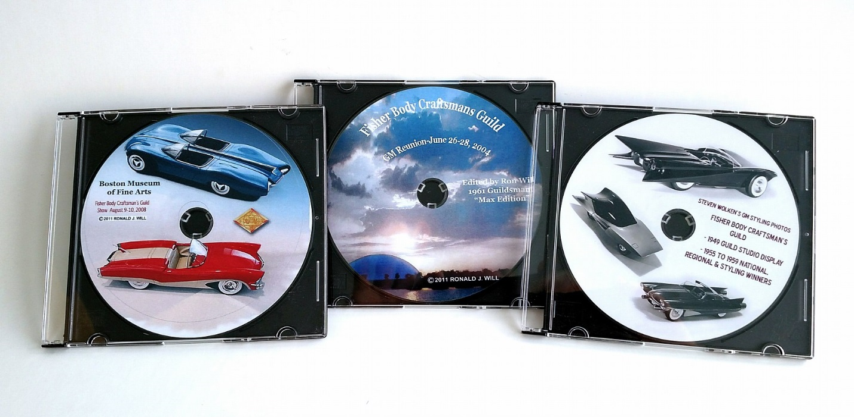

Ron Will is offering Three CDs packed with over 4,000 photos and files of GM Fisher Body Craftsman's Guild Model Cars, displays and history.

CD # 1 (Left with Red and Blue models) Focuses on the 2008 Boston Museum of Fine Arts Display and Reunion. It also contains early Guild literature, Historic pictures by decade, literature and Individual models.

CD # 2 (Middle photo of GM Tech Center) Focuses on the first Reunion in 2004 at the GM Design Center. This also contains more historic photos from 1946 to 1968 and a bonus section of Detroit Show cars and the GM Heritage Center of show car designs.

CD # 3 (Right with Black and White models) This CD contains the Original Guild Model Press photos from 1949 and 1955 to 1959. It also contains the Arizona Biltmore 2013 show, the Salt Lake City show and the Washington Smithsonian models. The early 1930’s coach models are also covered. \* (Note: There are a few duplicate photos from CD to CD.)

Purchase all three CDs for $25 or singles for $10 each. Postage is included.

Order from Ron Will, 15346 E. Verbena Dr., Fountain Hills, AZ 85268